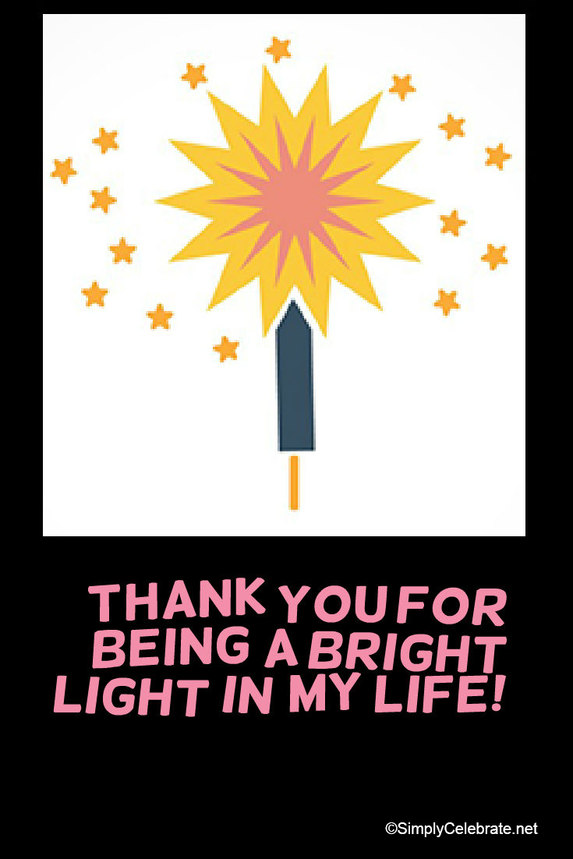
Dear

As the new year begins, I have been thinking a lot about 2016. One of the things that
stands out for me is my deep appreciation for you.

I want you to know that it meant so much to me during the past year when you

It feels important for me to thank you again for this because as I reflect upon the year, I see how much of an impact this has had on me.

Sometimes it is hard to put into words the ripple effects of someone’s kindness or gifts to us. Here’s how your thoughtfulness has boomeranged in such a positive way:

I hold you in my thoughts, with lots of love and gratitude.

The light you have given me shines brightly, leading me into 2017.

Thank you.

May 2017 be filled with
sparkles of joy + good health,

